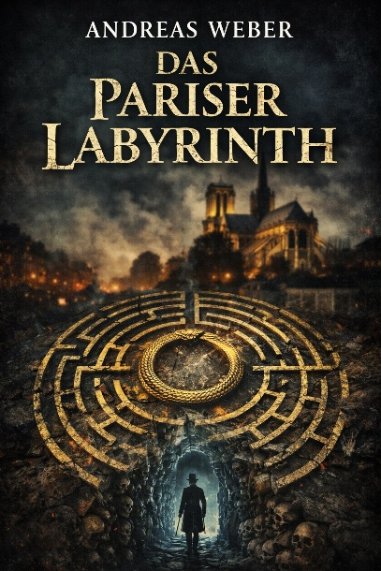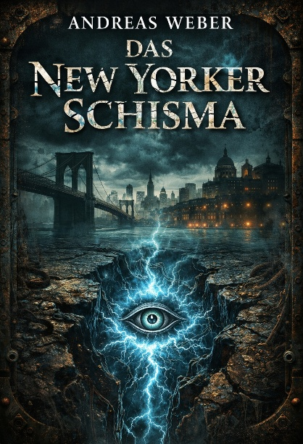

Einer der Liedtexte die aus der Historischen Thriller Trilogie hervorging.

Fire in the night

Fog on the river, fire in the night,
Old gods are sleeping under London’s light.

The city shakes beneath my feet,
Cold iron heartbeat in the street.
Gaslight flickers, thin and pale,
Like a dying prayer gone stale.
Brick and shadow, blood and steam,
Nothing here is what it seems.
Every doorway hides a sin,
Every smile is razor-thin.

And I hear the bells break open in the dark,
Like a warning, like a spark.

Where the Thames runs black tonight,
I still walk through smoke and fire.
Where the lost can’t find the light,
I still carry my desire.
Hear the city howl my name,
Hear the black sky split apart.
Where the Thames runs black tonight,
I’ve got London in my heart.

Cathedral stone and choking rain,
Velvet lies and iron chains.

Lords in windows dressed in gold,
Watch the lower city fold.
Children vanish in the mist,
Truth is something no one gives.
But under all this ash and grime,
Something waits its hour and time.

And I feel the streets come alive in the storm,
Like the dead are being reborn.

Where the Thames runs black tonight,
I still walk through smoke and fire.
Where the lost can’t find the light,
I still carry my desire.
Hear the city howl my name,
Hear the black sky split apart.
Where the Thames runs black tonight,
I’ve got London in my heart.

No savior comes, no banner flies,
Just broken truth and dirty lies.
No holy hand, no golden dawn,
Just the will to carry on.
Through the hunger, through the flame,
Through the guilt, through the shame,
Through the teeth of every night,
I still rise, I still fight.

Black river rising...
Old stone crying...
No use hiding...
London’s burning...

Where the Thames runs black tonight,
I still walk through smoke and fire.
Where the lost can’t find the light,
I still carry my desire.
Hear the city howl my name,
Hear the black sky split apart.
Where the Thames runs black tonight,
I’ve got London in my heart.Fog on the river, fire in the night,
And I’m still here when the morning dies

